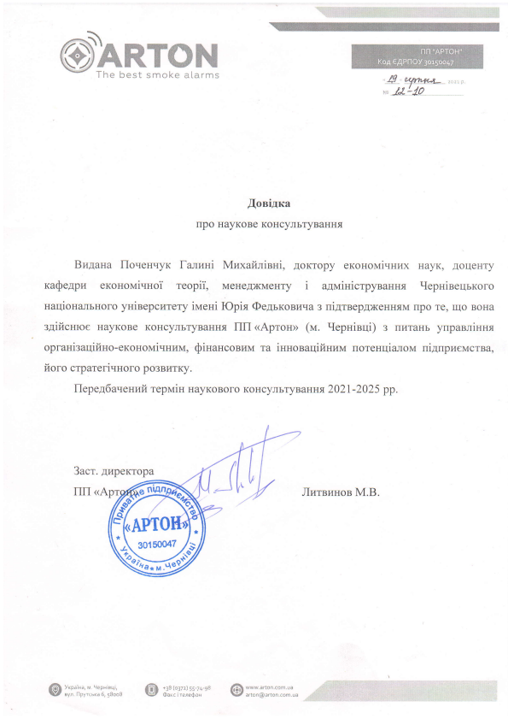
\.
@' WKffi,W ^{.I9} Xprt-t* , ,, /J40
Aoeitra
npo HayKoBe KoHcynbTyBaHHt
Bul.aua lloveuuyx fanr,rui Muxafininni, AoKropy er<oHorMi.{Hrax HayK, AoqeHTy r<a$e4pz erouolriquoi reopii, MeHeAXMeHry i aavrinicrpynannx ^{gepuineqbKoro} naqioualbHoro yninepcHrery irraeni lOpia @e4rr<onL.rra3 ni4rnepAxreHHrM rrpo re, rqo BoHa s4ificuroe HayKoBe KoHcynbryBaHHr lIlI <Aprou> (u. ^{gepnieqi)} a rr{raHb ynpanninnr opraHi:aqifiHo-erouol,ti.IHnN,r, _{SiuancoBr.rM} Ta iuHoearlifiHr4M rroreHrlialonr ni4upuenrcrBa, fioro crparerivHoro po3BzrKy.
flepe46au esuir repuin HayKoBoro KoHcynbryBaHHr 202 I -202 5 pp .
3acr.
nn( Jlurnunoe M.B.
.4\ ^{tev} _{'vv'} " w^{/ P}
APTO
30150047
+38 (o3rz) _{55-7a-98} $asr i rereScu
^{r} i r',i :l .al

