MINISTRY OF EDUCATION AND SCIENCE OF UKRAINE
HRYHORII SKOVORODA UNIVERSITY IN PEREIASLAV
INSTITUTE OF GEOGRAPHY. NATIONAL ACADEMY OF SCIENCES OF UKRAINE
INSTITUTE OF PEDAGOGY OF THE NAES OF UKRAINE

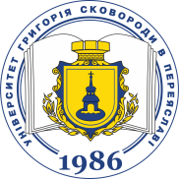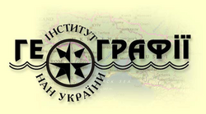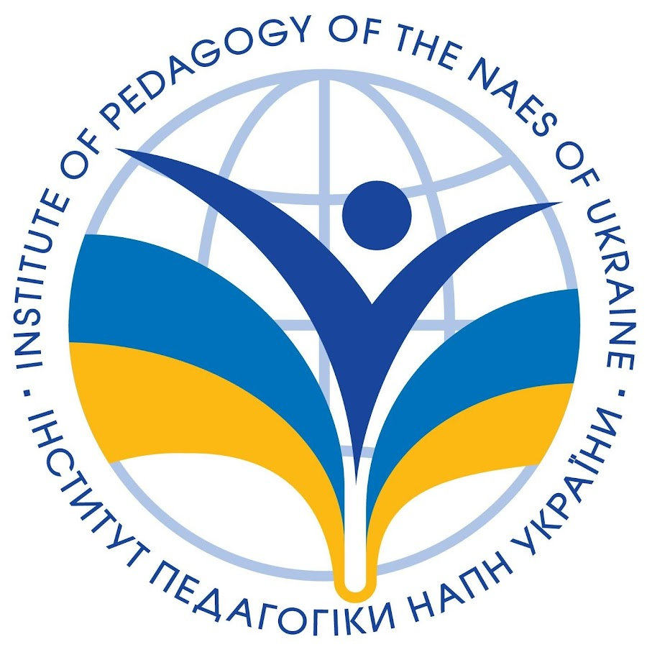

V INTERNATIONAL SCIENTIFIC AND PRACTICAL CONFERENCE

«GEOGRAPHICAL SCIENCE AND EDUCATION: PROSPECTS AND INNOVATIONS»

October 8-9, 2025

Dear colleagues, students, postgraduates, doctoral students, young scientists, researchers and scientific and pedagogical workers, we invite you to take part in the V International Scientific and Practical Conference “Geographical Science and Education: Prospects and Innovations”, which will be held on October 8-9, 2025 in Pereiaslav. Working languages of the conference: Ukrainian, English.

The aim of the conference is to discuss the potential of geographical science to respond to new policies, ideas, and practices that are being formed globally and in the EU in response to the main challenges of the 21st century. We are talking primarily about the consequences of Russian aggression on human capital, the settlement network, nature and economy of Ukraine, migration processes, and the aggravation of the environmental crisis as a result of the Russian-Ukrainian war. How are spatial structures and flows transformed at different levels? To what extent does the existing geographical methodology allow us to solve research problems and satisfy public demand? These are the key questions that will form the basis of the discussions. Separately, given the rapid development of information technology, the transformation of worldview values, and the role of acquired knowledge and skills, it is advisable to discuss the tasks, methods of geographic education, enlightenment, and scientific schools of geography in the context of war in Ukraine.

SCIENTIFIC AREAS OF THE CONFERENCE:

Area 1: Geographic education, enlightenment and scientific schools of geography in the context of war in Ukraine.
Area 2: Resilience, recovery and development of territories in the face of global and regional risks.
Area 3: Settlements, social and critical infrastructure of Ukraine's regions: destruction, damage and revitalization.

To participate in the conference, please send the following to olimp-geograf@ukr.net by September 15, 2025:

1. Application;

2. The text of the report;

3. Photo or scanned copy of the receipt of payment of the registration fee (after including the materials).

WORKING LANGUAGES: Ukrainian, English.

PARTICIPATION FORMAT: mixed.

The collection of reports is planned to be published before the start of the conference. The Organizing Committee reserves the right to reject materials that do not meet the topics and requirements of the conference, or those received later than the deadline.

E-mail: olimp-geograf@ukr.net.

Address of the Organizing Committee: Department of Ecology, Geography and Teaching Methods, Hryhorii Skovoroda University in Pereiaslav, 30, Sukhomlynskу Street, Pereiaslav, Kyiv region, 08401.

Contacts: Volovyk Liudmyla 063-828-17-70; Michuda Valeriia 063-663-77-91.

